**Online Food Ordering System**

**Use Case Analysis Document**

***27/04/2021***



**Approvals Signature Block**

|  |  |  |
| --- | --- | --- |
| **Project Responsibility** | **Signature** | **Date** |
| *Project Guide (Internal)* |  |  |
| *Project Guide (External)* |  |  |
| *Documentation Leader* |  |  |

*The document in this file is for UML Use Case Documentation Specifications, which conforms to the requirements of UML 2.0.*

*Items that are intended to stay in as part of your document are in* **bold***; blue italic text is used for explanatory information that should be removed when the template is used.*

**Table of Contents**

**1.** **GENERAL INFORMATION 3**

1.1 Version Control 4

1.2 Information Details 4

**2.** **USE CASE TEMPLATE 4**

**USE CASE # 4**

**3.** **USE CASE SPECIFIER LIST 6**

3.1 Use Case ID 6

3.2 Use Case Name 6

3.3 Use Case History 6

3.3.1 Created By 6

3.3.2 Date Created 6

3.3.3 Last Updated By 6

3.3.4 Date Last Updated 6

**4.** **USE CASE DEFINITION LIST 6**

4.1 Actors 6

4.2 Trigger 6

4.3 Description 6

4.4 Preconditions 7

4.5 Postconditions 7

4.6 Normal Flow 7

4.7 Alternative Flows 7

4.8 Exceptions 7

4.9 Includes 7

4.10 Priority 8

4.11 Frequency of Use 8

4.12 Business Rules 8

4.13 Special Requirements 8

4.14 Assumptions 8

4.15 Notes and Issues 8

**5.** **APPENDIX 8**

# **General Information**

|  |  |
| --- | --- |
| **Informational Item** | **Information** |
| Document Title | Use Case Name |
| Version | 1.0 |
| Subtitle | Use Case Subtitle. |
| Author | Shreya Hirapurkar, Vinayak Kokane, Dhanraj Kore, Vaishnavi Kulkarni |
| Project Name | Online Food Ordering System |
| Project Phase | Phase 1 |
| Project Iteration | 1 |

## **Version Control**

|  |  |  |  |
| --- | --- | --- | --- |
| **Date** | **Version** | **Description** | **Author** |
| April-27-2021 | 1.0 | In process | Shreya Hirapurkar, Vinayak Kokane, Dhanraj Kore, Vaishnavi Kulkarni |

## **Information Details**

|  |  |
| --- | --- |
| **Informational Item** | **Information** |
| Filename | C:\Documents and Settings\Terry\Desktop\Generic Use Case Template.doc |
| Last Saved On | Tuesday, April 27, 2021, 5:30:00 PM |
| Last Saved By | Shreya Hirapurkar, Vinayak Kokane, Dhanraj Kore, Vaishnavi Kulkarni |
| Number of Pages |  |

# **Use Case Template**

|  |  |  |
| --- | --- | --- |
| USE CASE 1 | Registration | |
| Goal | To create an interface where all primary actors can register themselves on the system. | |
| Purpose | Any user can create an account on our platform and start a way to find their delicious food. | |
| Preconditions | User entering into the system for the very first time. | |
| Success Condition | Confirmation mail regarding successful registration of the user | |
| Failed Condition | * Actors have to check mail and other credentials valid or not. * System will again ask them to register. | |
| Postconditions | After login, Users will be directed to the login page. | |
| Primary Actors | Customer and Restaurant Employees | |
| Secondary Actors | Google and Facebook database handlers | |
| Trigger | Clicking upon Sign-up button | |
| DESCRIPTION | Step | Basic Course of Action |
|  | 1 | To become an authenticated user of the system, new customers and restaurant employees have to register on the system.  They have to click on sign-up button |
|  | 2 | On the sign-up page, fill all the required credentials |
|  | 3 | Verify mail and that’s it |
| DESCRIPTION | Step | Error Scenario |
|  | 1 | If error occurs, check whether mail is valid or not |
|  | 2 | If it is valid, mail must have been sent to verify the user. Verify it. |
|  | 3 | If not, re-register with valid mail |

|  |  |
| --- | --- |
| RELATED INFORMATION | Registering User |
| Priority: | Very Important |
| Superordinates | NA |
| Subordinates | NA |

# 

# **Use Case Specifier List**

## **Use Case ID**

Use Case ID- 1

## **Use Case Name**

Registration

## **Use Case History**

### **Created By**

*Shreya Hirapurkar, Vinayak Kokane, Dhanraj Kore, Vaishnavi Kulkarni*

### **Date Created**

***27/04/2021***

### **Last Updated By**

***27/04/2021****.*

### **Date Last Updated**

***27/04/2021***

# **Use Case Definition List**

## **Actors**

Primary Actors

* Customer
* Restaurant Employees

Secondary Actors

* Google and Facebook database handlers

## **Trigger**

Clicking upon Sign-up button

## **Description**

Any user can create an account on our platform and start a way to find their delicious food.

## **Preconditions**

After login, Users can proceed for further food booking processes.

## **Postconditions**

After login, Users can proceed for further food booking processes.

## **Normal Flow**

1.1 When the user opens the URL for the first time, he or she will be asked to register for seamless experience of the site.

1.2 They need to click on the Sign-up button and follow all the instructions to complete the process.

1.3 After successful registration they will be taken to the home page of the site.

## **Alternative Flows**

1.1 Alternate course of action is that the user can link their Google or Facebook account.

1.2 Once they verify via 3rd party app, they will be directed to the home page as a registered member.

## **Exceptions**

1.1 If the user tries an already registered email id, they will be shown an error message stating that the id is already being in use.

1.2 Weak password (less characters) will not be allowed.

## **Includes**

NA

## **Priority**

Very High Preference.

## **Frequency of Use**

It is a one-time process. After the user has registered, he/she will only require their Email-id and password to login into their account.

## **Business Rules**

NA

## **Special Requirements**

NA

## **Assumptions**

NA

## **Notes and Issues**

NA

|  |  |  |
| --- | --- | --- |
| USE CASE 2 | Log-in | |
| Goal | To create an interface where all primary actors can log-in themselves on the system. | |
| Purpose | Registered users can now login to an account on our platform and start a way to find their delicious food. | |
| Preconditions | Must be registered first | |
| Success Condition | * Actors are now logged-in. * The system will display all associated features as defined. | |
| Failed Condition | * Actors have to check whether they are registered on the system or not and also to check whether entered credentials are correct or not. * System will again ask them to log-in. | |
| Postconditions | After successful login, users will be directed to the home page of our website. | |
| Primary Actors | Customer and Restaurant Employees | |
| Secondary Actors | Google and Facebook database handlers | |
| Trigger | Clicking upon Log-in button or immediately after successful registration | |
| DESCRIPTION | Step | Basic Course of Action |
|  | 1 | To log-in to the system, customers and restaurant employees have to click on the log-in button or they can be automatically directed on log-in page after newly registration |
|  | 2 | On the log-in page, fill all the required credentials |
| DESCRIPTION | Step | Error Scenario |
|  | 1 | If error occurs, check whether the entered credentials are correct or not |
|  | 3 | If not, again log-in with correct credentials. |

|  |  |
| --- | --- |
| RELATED INFORMATION | Logging in the User |
| Priority: | Very Important |
| Superordinates | NA |
| Subordinates | NA |

# 

# Use Case Specifier List

## Use Case ID

Use Case ID- 2

## Use Case Name

Login

## Use Case History

### Created By

*Shreya Hirapurkar, Vinayak Kokane, Dhanraj Kore, Vaishnavi Kulkarni*

### Date Created

***27/04/2021***

### Last Updated By

***27/04/2021****.*

### Date Last Updated

***27/04/2021***

# Use Case Definition List

## Actors

Primary Actors

* Customer
* Restaurant Employees

Secondary Actors

* Google and Facebook database handlers

## Trigger

Clicking upon Log-in button or after successful registration

## Description

Registered users can now login to an account on our platform and start a way to find their delicious food.

## Preconditions

Registration

## Postconditions

After login, Users can proceed for further food booking processes.

## Normal Flow

1.1 When the user registers on the system for the first time, he or she will be asked to login for seamless experience of the site.

1.2 They need to click on the Login button and follow all the instructions to complete the process.

1.3 After successful login they will be taken to the home page of the site.

## Alternative Flows

1.1 Alternate course of action is that the user can login directly through their Google or Facebook account.

1.2 Once they verify via 3rd party app, they will be directed to the home page as a logged in member.

## Exceptions

1.1 If the user enters an incorrect email id or password, they will be shown an error message.

## Includes

NA

## Priority

Very High Preference.

## Frequency of Use

After the user has registered, he/she will only require their Email-id and password to login into their account.

## Business Rules

NA

## Special Requirements

NA

## Assumptions

NA

## Notes and Issues

NA

|  |  |  |
| --- | --- | --- |
| USE CASE 3 | Select item | |
| Goal | To create an interface where customers can select food items displayed on the system after successful login. | |
| Purpose | Selection of favourite food item | |
| Preconditions | Must be logged in user | |
| Success Condition | Bill will be generated | |
| Failed Condition | NA | |
| Postconditions | Users can proceed for further food booking processes. | |
| Primary Actors | Customers | |
| Secondary Actors | Restaurant employees | |
| Trigger | Clicking upon Add-item button | |
| DESCRIPTION | Step | Basic Course of Action |
|  | 1 | After choosing a delicious food from their food category, customers can simply add items into the pool |
|  | 2 | Collective bill will be generated |
| DESCRIPTION | Step | Error Scenario |
|  | 1 | If error occurs, check whether there is stable internet connection or not |

|  |  |
| --- | --- |
| RELATED INFORMATION | Selections of food items |
| Priority: | Very Important |
| Superordinates | NA |
| Subordinates | NA |

# 

# Use Case Specifier List

## Use Case ID

Use Case ID- 3

## Use Case Name

Select item

## Use Case History

### Created By

*Shreya Hirapurkar, Vinayak Kokane, Dhanraj Kore, Vaishnavi Kulkarni*

### Date Created

***27/04/2021***

### Last Updated By

***27/04/2021****.*

### Date Last Updated

***27/04/2021***

# Use Case Definition List

## Actors

Primary Actors

* Customer

Secondary Actors

* Restaurant Employees

## Trigger

Clicking upon the Add-item button

## Description

Selection of favourite food item.

## Preconditions

Login

## Postconditions

After selection of food items, Users can proceed for further food booking processes.

## Normal Flow

1.1 When the user selects food-items, he or she will be can check bill generated

1.2 They need to click on the view cart button to review the food items.

## Alternative Flows

NA

## Exceptions

NA

## Includes

NA

## Priority

Very High Preference.

## Frequency of Use

Whenever customer feels hungry, they can simply select their delicious food from provided food items as many times they want

## Business Rules

NA

## Special Requirements

NA

## Assumptions

NA

## Notes and Issues

NA

|  |  |  |
| --- | --- | --- |
| USE CASE 4 | Book and review order | |
| Goal | To create an interface where customers can book food orders efficiently. | |
| Purpose | Booking of food items | |
| Preconditions | Must have selected food items into the pool | |
| Success Condition | Order will be placed | |
| Failed Condition | Order fails | |
| Postconditions | Rating and provide a review | |
| Primary Actors | Customers | |
| Secondary Actors | Restaurant employees | |
| Trigger | Clicking upon place-order button | |
| DESCRIPTION | Step | Basic Course of Action |
|  | 1 | After choosing a delicious food from their food category, customers can simply add items into the pool |
|  | 2 | Now customer can review order and pay for that |
| DESCRIPTION | Step | Error Scenario |
|  | 1 | If error occurs, check whether there is stable internet connection or not |

|  |  |
| --- | --- |
| RELATED INFORMATION | Review orders |
| Priority: | Very Important |
| Superordinates | NA |
| Subordinates | NA |

# 

# Use Case Specifier List

## Use Case ID

Use Case ID- 4

## Use Case Name

Review orders

## Use Case History

### Created By

*Shreya Hirapurkar, Vinayak Kokane, Dhanraj Kore, Vaishnavi Kulkarni*

### Date Created

***27/04/2021***

### Last Updated By

***27/04/2021****.*

### Date Last Updated

***27/04/2021***

# Use Case Definition List

## Actors

Primary Actors

* Customer

Secondary Actors

* Restaurant Employees

## Trigger

Clicking upon the place-order button

## Description

Reviewing order summary.

## Preconditions

Selection of food items

## Postconditions

After booking of food items, Users can track the booking processes.

## Normal Flow

1.1 When the user selects food-items, he or she will be can check bill generated

1.2 They need to click on the place-order button to review the food items.

## Alternative Flows

NA

## Exceptions

NA

## Includes

NA

## Priority

Very High Preference.

## Frequency of Use

Whenever customer feels hungry, they can simply select their delicious food from provided food items as many times they want and book

## Business Rules

NA

## Special Requirements

NA

## Assumptions

NA

## Notes and Issues

NA

|  |  |  |
| --- | --- | --- |
| USE CASE 5 | Pay for order | |
| Goal | To create payment gateway where customers can pay and book food orders efficiently. | |
| Purpose | Booking of food items | |
| Preconditions | Must have reviewed food items | |
| Success Condition | Order will be placed | |
| Failed Condition | Payment might fails due to technical errors of associated banks | |
| Postconditions | Rating and provide a review | |
| Primary Actors | Customers | |
| Secondary Actors | Restaurant employees | |
| Trigger | Clicking upon Pay button | |
| DESCRIPTION | Step | Basic Course of Action |
|  | 1 | After choosing a delicious food from their food category, customers can simply add items into the pool |
|  | 2 | Now customer can review order and pay for that |
| DESCRIPTION | Step | Error Scenario |
|  | 1 | * If error occurs, check whether there is stable internet connection or not * Or check for banks payment status |

|  |  |
| --- | --- |
| RELATED INFORMATION | Pay for orders |
| Priority: | Very Important |
| Superordinates | NA |
| Subordinates | NA |

# 

# Use Case Specifier List

## Use Case ID

Use Case ID- 5

## Use Case Name

Pay for orders

## Use Case History

### Created By

*Shreya Hirapurkar, Vinayak Kokane, Dhanraj Kore, Vaishnavi Kulkarni*

### Date Created

***27/04/2021***

### Last Updated By

***27/04/2021****.*

### Date Last Updated

***27/04/2021***

# Use Case Definition List

## Actors

Primary Actors

* Customer

Secondary Actors

* Restaurant Employees

## Trigger

Clicking upon the pay button

## Description

Payment for orders from 3 different sources

* UPI
* Debit Card
* Credit Card
* Net Banking

## Preconditions

Selection of food items

## Postconditions

After Payment of food items, Users can track the booking processes.

## Normal Flow

1.1 When the user selects food-items, he or she will be can check bill generated

1.2 They need to click on the place-order button to review the food items.

## Alternative Flows

NA

## Exceptions

NA

## Includes

NA

## Priority

Very High Preference.

## Frequency of Use

Whenever customer feels hungry, they can simply select their delicious food from provided food items as many times they want and pay to book order

## Business Rules

NA

## Special Requirements

NA

## Assumptions

NA

## Notes and Issues

NA

|  |  |  |
| --- | --- | --- |
| USE CASE 6 | Add or Remove food items | |
| Goal | To create an interface where restaurant employees can add and remove food items efficiently. | |
| Purpose | According to restaurants menu, restaurant employees can add or delete food items on the system | |
| Preconditions | Must have predefined food menu | |
| Success Condition | Food items will be added or deleted | |
| Failed Condition | NA | |
| Postconditions | Keep a log about food items | |
| Primary Actors | Restaurant employees | |
| Secondary Actors | Customers | |
| Trigger | Clicking on Add/Remove button | |
| DESCRIPTION | Step | Basic Course of Action |
|  | 1 | After setting up a food category menu, emplyees can simply add items or remove items into the system |
|  | 2 | Now customer can view the respective changes |

|  |  |
| --- | --- |
| RELATED INFORMATION | Add or Remove food items |
| Priority: | Important |
| Superordinates | NA |
| Subordinates | NA |

# 

# Use Case Specifier List

## Use Case ID

Use Case ID- 6

## Use Case Name

Add or Remove food items

## Use Case History

### Created By

*Shreya Hirapurkar, Vinayak Kokane, Dhanraj Kore, Vaishnavi Kulkarni*

### Date Created

***27/04/2021***

### Last Updated By

***27/04/2021****.*

### Date Last Updated

***27/04/2021***

# Use Case Definition List

## Actors

Primary Actors

* Restaurant Employees

Secondary Actors

* Customer

## Trigger

Clicking upon the add/remove items button

## Description

According to restaurants menu, restaurant employees can add or delete food items on the system

## Preconditions

Restaurant food menu

## Postconditions

Keep a log about food items

## Normal Flow

1.1 When an employee adds/removes food-items,customer will be able to check updations

## Alternative Flows

NA

## Exceptions

NA

## Includes

NA

## Priority

High Preference.

## Frequency of Use

Employees can add/remove items at any time according to their menu

## Business Rules

NA

## Special Requirements

NA

## Assumptions

NA

## Notes and Issues

NA

|  |  |  |
| --- | --- | --- |
| USE CASE 7 | Receive Confirmation | |
| Goal | To create an admin side interface where admin can receive confirmations of orders from users. | |
| Purpose | Admin will be able to manage the whole system, both customers and restaurant employees. It will receive confirmations of orders | |
| Preconditions | Must have Navigate menu | |
| Success Condition | Food orders will be displayed | |
| Failed Condition | NA | |
| Postconditions | Proceed further to control the orders | |
| Primary Actors | Admin | |
| Secondary Actors | Restaurant employees and Customers | |
| Trigger | Triggered when users places an order | |
| DESCRIPTION | Step | Basic Course of Action |
|  | 1 | After booking an order, the admin will be notified with that. |
|  | 2 | Now admin can view the order summaries. |

|  |  |
| --- | --- |
| RELATED INFORMATION | Receive Confirmation |
| Priority: | Important |
| Superordinates | NA |
| Subordinates | NA |

# 

# Use Case Specifier List

## Use Case ID

Use Case ID- 7

## Use Case Name

Receive Confirmation

## Use Case History

### Created By

*Shreya Hirapurkar, Vinayak Kokane, Dhanraj Kore, Vaishnavi Kulkarni*

### Date Created

***27/04/2021***

### Last Updated By

***27/04/2021****.*

### Date Last Updated

***27/04/2021***

# Use Case Definition List

## Actors

Primary Actors

* Admin

Secondary Actors

* Customer and restaurant employees

## Trigger

Triggered when users places an order

## Description

Admin will be able to manage the whole system, both customers and restaurant employees. It will receive confirmations of orders.

## Preconditions

Placing of orders form users

## Postconditions

Approval/Disapproval

## Normal Flow

1.1 When customer places an order, admin will be able to check them

## Alternative Flows

NA

## Exceptions

NA

## Includes

NA

## Priority

Very High Preference.

## Frequency of Use

Admin has to check for all the orders received from users side

## Business Rules

NA

## Special Requirements

NA

## Assumptions

NA

## Notes and Issues

NA

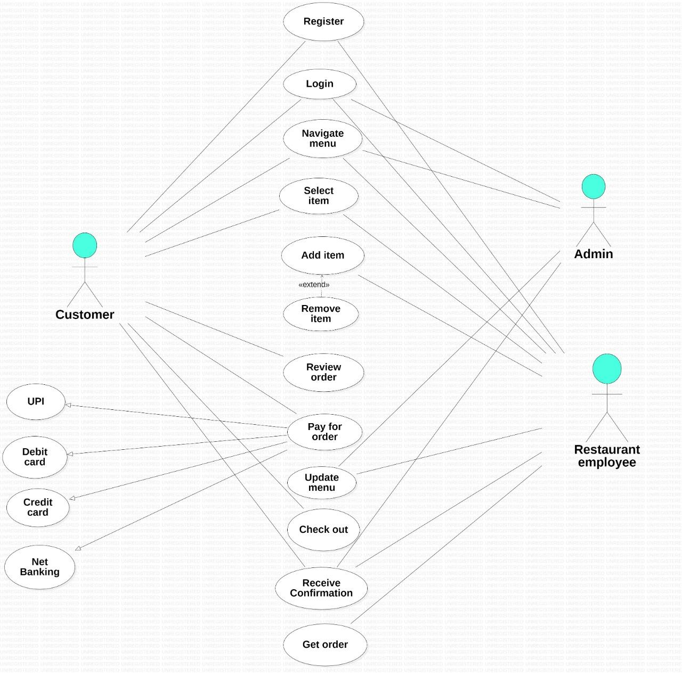

Fig.1.**Use Case Diagram** of Online food ordering system